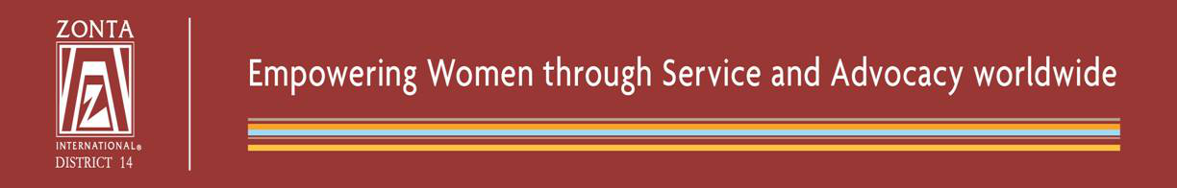

Dear Governors, dear Zontians,

concerning the 7th European Seminar we are very proud that so many Zontians registered for the Seminar, but we are also very sorry, that we had to close the registration on November 3rd 2016 after the deadline of October 31st, as we are fully booked.
We thank you all for your interest in the Seminar and we kindly ask you to understand, that we have to respect the security and safety regulations of the venue. The seminar is calculated on a very reasonable registration fee. As volunteers for a Service Organization we did not book a commercial conference centre but a seminar centre with a capacity of 250 persons, based on the average participation of the last seminars.
Our treasurer Eva Maria Kodek-Werba confirmed all registrations and payments, but there are still unidentified payments without registration forms and open payments. Therefore she provided a waiting list of the late registrations.
As you know, there will be a ZONTA INTERNATIONAL leadership training on Friday 3rd, morning and afternoon. This might be also of interest to come to Vienna. Participation is still possible, please contact Maureen Heine: maureen@meton.co.nz.
See the programe at:
http://zonta-district14.org/wp-content/uploads/2016/07/flyerLDT.jpg
Once again, we will do our best for a pleasant stay in Vienna and we are really sorry not to be able to accept further registrations.
The organizing team:
Ingeborg Geyer (Chairperson)
Margot Fleck (Vice Chairperson)
Eva Maria Kodek-Werba (Treasurer)
Mia Matysek (Secretary)
Christine Zöchling (Eventbooking)
Gerda Senkyr (Sponsoring)

Vienna, November 9th, 2016

