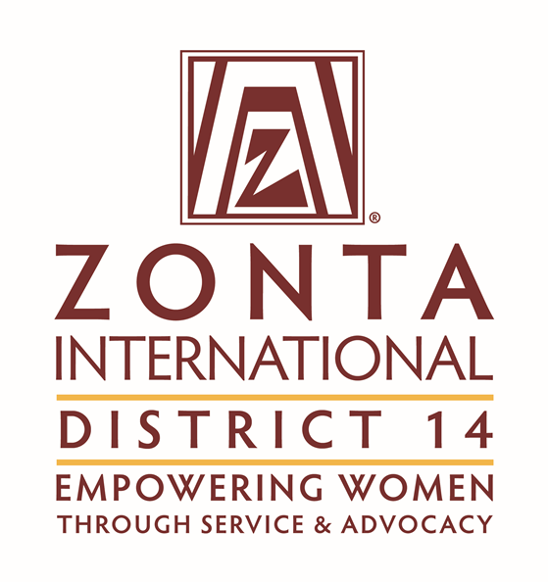

Zonta D14 STEM Award
2022 Application

Zonta D14 STEM Award

General Information
Women are still largely underrepresented in technology and other STEM (Science Technology Engineering Mathematics) fields. To create a world in which men and women have equal opportunities, women need to have an active role in technology and technological developments. Zonta District 14 is pleased to offer its Zonta D14 STEM Award to encourage women to pursue education, career opportunities and leadership roles in technology.

The Award
The Zonta D14 STEM Award is awarded to women of any age, pursuing a degree in STEM. Zonta District 14 (D14) offers an Award in the amount of 2000€.

Who is Eligible?
Women of any age and nationality, pursuing a degree in STEM at an accredited university/college/institute, who demonstrate outstanding academic record during their academic studies in STEM, are eligible to apply.

Students must be enrolled in at least the second year of an undergraduate program through the final year of a Master's program at the time the application is submitted to the local Zonta club. Applicants must still be in school at the time the awards are disbursed and must not graduate before December 2022.

Golden Z club members may apply.
Classified members and employees of Zonta International and Zonta International Foundation, and their family members, are not eligible to apply.

How Do I Apply?
Complete an official application in English. Please note that only typed applications will be accepted and considered. All non-English documents must be translated into English. The following documents are to be submitted in the application package. Applications can be downloaded from the Zonta D14 website, (https://zonta-district14.org/and must include:

- Verification of Current Enrollment form or official statement from the university/college registrar.
- List and include official detailed transcripts of grades or equivalent records from all universities, colleges, or institutions attended, including undergraduate institutions and degrees received. In programs where graduate transcripts are not provided as a matter of institutional policy, please provide a statement of that policy from the registrar or other school official. (Important note: please do not upload electronic transcripts, or links to electronic copies directly from the university, as the documents may have expiration dates to review and/or request for a password to access the file. Please scan official transcripts in color and save as a PDF and upload the saved copy. Please ensure all transcripts are legible.) Do not upload unofficial transcripts as they will not be accepted.
- Two confidential recommendations from a faculty member in the major field of study. (Classified members and employees of Zonta International and Zonta Foundation for Women are not eligible to write recommendation letters for applicants.)
- List scholarships and honors received, if any.
- All non-English documents must be translated into English to be considered.
- Information other than official transcripts and recommendations must be limited to the space provided; attachments, articles, pamphlets, books, curriculum vitae or other publications are not requested and will not be considered.

Application Process
The Zonta D14 STEM Award program operates at the club and district level of Zonta district 14. Applications selected by Zonta clubs are sent to the respective Zonta district 14 governor. The Zonta D14 STEM Award Committee selects tree recipients from the applicants.

Timetable
Applications received by Zonta clubs ________ 2022
Club recipient is selected, and application is received by governor representative 1 October 2022
Official announcement of district recipients mid-November 2022

Application for Zonta D14 STEM Award
SEND APPLICATION AND DIRECT ANY QUESTIONS TO:
Application Deadline:
Zonta Club of:
District/Area:
To find a club click: | Club Locator
Attention:
Address:
City/State:
Province/Country:
Telephone:
Email address:

Name:
 | Last (Family) | First | Middle

Current mailing address:

City: |  | State: |  | Postal Code: |  | Country:

Email address: |  | Telephone:

LinkedIn address:

Twitter handle:

Permanent mailing address:

City: |  | State: |  | Postal Code: |  | Country:

Home email address: |  | Telephone:

Birth date: |  | Birthplace: |  | Country of citizenship:
(date/month/year)
Name of university/college/institute currently attending:

Current year of study:

Department: |  | Major/field of study:

Plans for study under the Zonta D14 STEM Award:

Degree sought:

Expected graduation date (if applicable provide month/year):

Academic Background:
Applicants are required to send transcripts of grades or equivalent records from all universities, colleges or institutes attended. An explanation of the grading system must be included for each transcript. Please add your current degree sought and expected graduation date (month/year).

University/college/institute/online | (Year) to (Year) | Major field | Date of degree/anticipated

Employment History in the Technology Field:
From (month/year) | To (month/year) | Name of Employer | Address | Type of work or position held

Scholarships, Fellowships, Honors Received During the Studies Listed Above
(Attach an additional sheet if necessary)

Date:
Date:
Date:
Date:
Date:
Date:
Date:

Volunteer and Other Activities
(Please describe your volunteer, non-scholastic activities, memberships and cultural interests):

Recommendations
Please give one of the attached recommendation forms to a faculty member in the major field of study.

Please list below those who will submit recommendations:

Name | Position | College/university/institute/employer
1.
2.

Declaration by Applicant
I grant permission to Zonta district 14 and Zonta Club to use my name and photograph in the literature designed to promote Zonta D14 STEM Award.
I certify that all the information contained in my application form is accurate to the best of my knowledge. I understand that, at the option of the Zonta club or the Zonta district sponsoring my application, I may be interviewed as a candidate for the Zonta D14 STEM Award. I consent to the electronic or hard copy publication of material in my application by Zonta.
- I confirm that I have not applied to more than one Zonta Club.
- I confirm that I am not a family member of a classified member and/or employee of Zonta.
Signature (required) |  | Date

(Insert image of your signature or print, sign and scan this page.)

Applicant checklist

Please check all items included with the application:
Completed application in English
Official copies of transcripts
Recommendation letter cover sheets with dates and signatures
Recommendation Letters (2)
Essay (not exceeding 500 words)
Verification of current enrollment form with official stamp of the college/university/institute
Signatures

How did you learn of the Zonta D14 STEM Award?

Please check the appropriate items:
Social media
Facebook
LinkedIn
Other: ______________________________________
Department/teacher
Diversity office
Directory of grants at university financial aid office
Directory of grants not at university (e.g., public libraries)
Website (name):
Zonta club member:
Zonta Club of:
Other:

Data Protection
Zonta Club and Zonta district 14 take the security of your data seriously. We will never sell, trade, or rent your personal information provided in this application to third parties. By submitting this application, you agree to the use of your data in accordance with the Privacy Policy and Publicity Authorization Form contained in the application documents (see page11 of the application).

PROFESSIONAL INFORMATION AND GOALS

(Please type essay in English.)
In 500 words or less, please describe your academic and/or professional goals, the relevance of your program in the technology field, and how the Zonta D14 STEM Award will assist you in reaching your goals. (Essays cannot exceed 500 words to be considered.)

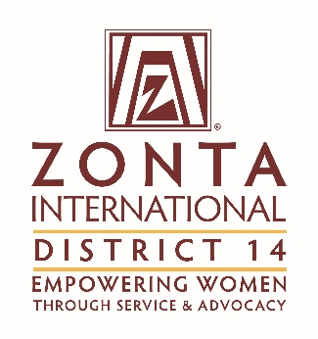

Recommendation for the Zonta D14 STEM Award

Please return this form by:

Applicant’s Signature is required (Insert image of your signature or print, sign and scan this page.)

Applicant:
 |  | Last (Family) Name |  | First |  |  | Middle
Recommendation from:
 |  |  | Name |  |  | Position/Title

College/university/institute/employer

The applicant above has applied for a Zonta D14 STEM Award. The Zonta D14 STEM Award Evaluation Committee greatly values and appreciates your opinion. Please discuss the applicant’s accomplishments; current academic program and/or work experience; intellectual independence; capacity for analytical thinking; ability to organize and express ideas clearly; creativity; motivation; and potential for learning and succeeding in the STEM related program. You may write your recommendation letter on letterhead of your choice, sign and must submit with this form.
How long have you known the applicant?
Please rate the applicant with respect to your experience with other students/employees in this field/position:
Exceptional  Top 5% | Very Good  Next 10% | Good  Next 15% |  | Average  Next 30% | Below Average  Last 40% |  | Insufficient opportunity to observe

Signature is required (Insert image of your signature or print, sign and scan this page.) |  | Date

Return form to Zonta Club of: |  | Address: |  | City:
State/Province: |  | Country: |  | Postal Code:
Fax: |  | Email address:

Recommendation for the Zonta D14 STEM Award

Please return this form by:

Applicant’s Signature is required (Insert image of your signature or print, sign and scan this page.)

Applicant:
 |  | Last (Family) Name |  | First |  |  | Middle
Recommendation from:
 |  |  | Name |  |  | Position/Title

College/university/institute/employer

The applicant above has applied for a Zonta D14 STEM Award. The Zonta D14 STEM Award Evaluation Committee greatly values and appreciates your opinion. Please discuss the applicant’s accomplishments; current academic program and/or work experience; intellectual independence; capacity for analytical thinking; ability to organize and express ideas clearly; creativity; motivation; and potential for learning and succeeding in the STEM related program. You may write your recommendation letter on letterhead of your choice, sign and must submit with this form.

How long have you known the applicant?
Please rate the applicant with respect to your experience with other students/employees in this field/position:
Exceptional  Top 5% | Very Good  Next 10% | Good  Next 15% |  | Average  Next 30% | Below Average  Last 40% |  | Insufficient opportunity to observe

Signature is required (Insert image of your signature or print, sign and scan this page.) |  | Date

Return form to Zonta Club of: |  | Address: |  | City:
State/Province: |  | Country: |  | Postal Code:
Fax: |  | Email address:

Verification of Current Enrollment
Zonta D14 STEM Award

I certify that |  | is currently enrolled in
 | (name of student)

 | in
(year of degree program) |  | (name of course/degree being studied)

at
(name of college/university/institute)

(address college/university/institute)

(signature of college/university/institute official)

(official stamp of the college/university/institute)

This requirement may be deferred if the application deadline precedes the university/college/institute enrollment period. The applicant must provide written confirmation of the enrollment period with the application.

Zonta D14 STEM Award

Privacy Policy and Publicity Authorization

Zonta Club and the Zonta district 14 are committed to honoring the privacy and wishes of all of our Zonta D14 STEM Award recipients at all times. In order to do this, please read the following information carefully and indicate your agreement as appropriate.

- Most data collected by Zonta Club and the Zonta district 14 is used only to help Zonta better serve its Award recipients. It is our general policy to collect and store only personal information that our recipients knowingly provide. Zonta does not sell, trade, or rent your personally identifying information to third parties. We take reasonable measures not to disclose personally identifying information about you.
I have read the above paragraph and agree to the Terms and Conditions therein.

- From time to time, Zonta Club and the Zonta district 14 conducts various marketing activities to promote the Zonta D14 STEM Award Program. In addition, to ensure Zonta’s ability to fund the Awards, the Zonta district 14 may from time to time provide information to donors to the Zonta D14 STEM Award about recipients of their donations. Zonta retains the right to use your name, photograph and biographical information to promote the Zonta D14 STEM Awards in various promotional materials, including the website.
I have read the above paragraph and agree to the Terms and Conditions therein.

Signature (Insert image of your signature or print, sign and scan this page.) |  | Date

Please print your name

